Parenting Support and Community Integration Worker
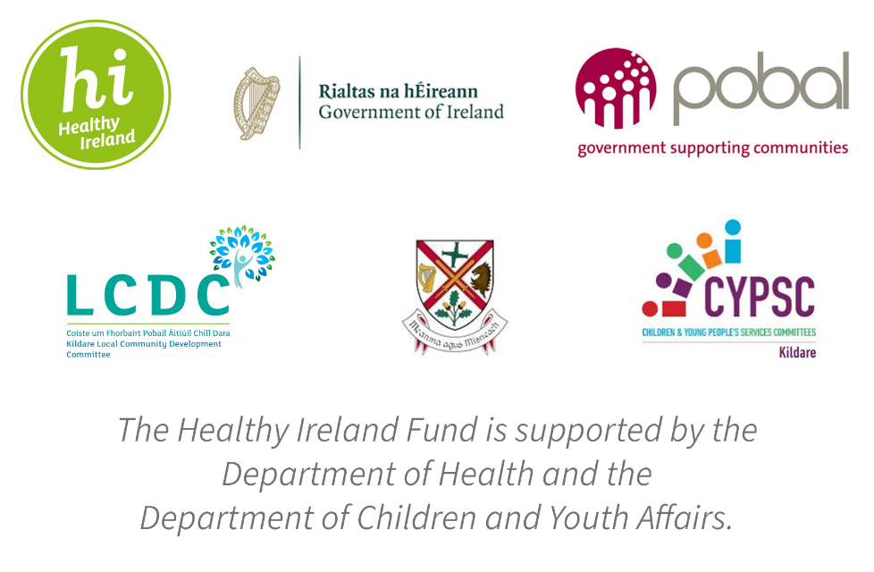

Reporting: Head of Services with Responsibility for Family Services
Contract: Fixed Term Contract 28 hours per week
About Peter McVerry Trust: Established in 1983 by Fr Peter McVerry the charity works with individuals at risk of, or experiencing homelessness, primarily in the Dublin region. Peter McVerry Trust provides a wide range of services in the areas of prevention, housing, homelessness, under 18s residential and drug treatment.
Our Vision: “An Ireland that supports all those on the margins and upholds their rights to full inclusion in society.”
Our Mission: Peter McVerry Trust is committed to reducing homelessness and the harm caused by drug misuse and social disadvantage. Peter McVerry Trust provides low-threshold entry services, primarily to younger persons with complex needs, and offers pathways out of homelessness based on the principles of the Housing First model and within a framework that is based on equal opportunities, dignity and respect.

To employ a Parenting Support and Community Integration Worker who will engage with families placed in Family Hubs in Kildare County Council Area during and after their placements.

- Key Responsibilities and Duties:

- To work for Peter McVerry Trust within the authority delegated to him/her by the Manager/Team Leader/Social Care Leader;
- Meet with the Manager/Team Leader/Social Care Leader at regular intervals regarding the progress of his/her work;
- To assist the Manager/Team Leader/Social Care Leader in the day to day running of the project.

2. To provide direct support to residents through:

- Working with families who are placed in the hubs in relation to offering support to build capacity in relation to parenting skills.
- To support families to sustain themselves during a period of homelessness and continue to support children to achieve their key developmental milestones during a period of instability. It will provide clear benefits to both parents and children and ensure that the skills acquired perpetuate into the future and post homelessness.
- To ensure that the family receive the best possible support to acquire and embed the parenting skills, the interventions will continue after the family have progressed to housing to ensure that continuity.
- Supports post progression will also include a community integration element whereby families are facilitated to engage positively in pro-social engagement and relationships in the new community in which they now live.

Person Specification:

Essential competencies:
- Commitment to providing the highest level of service, communication skills– oral, aural and written, openness to change
- Effective team working, ability to work on own initiative, professionalism, respect for others, focus on outcomes, contributing to the prevention and management of challenging behaviour and resilience and positive outlook
- Capacity to work on own initiative and achieve agreed outcomes and targets in relation to interventions offered to families.

Qualifications:

Degree level qualification in Psychology, Social Care, Social Science, Sociology, Social Policy or other related disciplines.

To apply, please download the PMVT application form from http://www.pmvtrust.ie/about-us/vacancies/.
Completed application forms should be sent to recruitment@pmvtrust.ie

Closing date is 20th March 2020

Peter McVerry Trust is an Equal Opportunity Employer

Peter McVerry Trust Operations Ltd Registration Number 412953 Charity Number CHY7256

