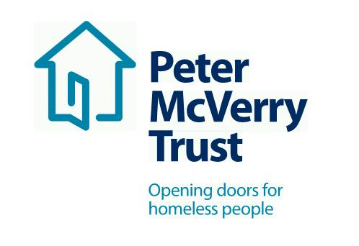

SOCIAL CARE WORKER - RELIEF CONTRACT

Title of Post: Social Care Worker

We are hiring for Relief Social Care Workers, this is a 3 month Relief Contract with immediate start. Please apply to recruitment@pmvtrust.ie
- Interviews being held by SKYPE
- Full training carried out on line before start date
- Immediate start when training completed

About Peter McVerry Trust: Established in 1983 by Fr Peter McVerry, the charity works with individuals at risk of, or experiencing homelessness, in counties Dublin, Kildare, Laois and Limerick. Peter McVerry Trust provides a wide range of services in the areas of homelessness prevention, family services, housing, homeless services, under 18s residential services, and drug treatment.

Our Vision: “An Ireland that supports all those on the margins and upholds their rights to full inclusion in society.”

Our Mission: Peter McVerry Trust is committed to reducing homelessness, the harm caused by drug misuse and social disadvantage. Peter McVerry Trust provides low-threshold entry services, primarily to younger persons with complex needs, and offers pathways out of homelessness based on the principles of the Housing First model within a framework that is based on equal opportunities, dignity and respect.

Key Responsibilities and Duties:

- To work for Peter McVerry Trust within the authority delegated to him/her by the Manager/Team Leader/Social Care Leader;
- Meet with the Manager/Team Leader/Social Care Leader at regular intervals regarding the progress of his/her work;
- To assist the Manager/Team Leader/Social Care Leader in the day to day running of the project.

2. To provide direct support to residents through:

- Intervention, support and supervision;
- When required, advocacy and referral to community services;
- Supervising the behavior of the residents at all times;
- Liaising with the appropriate staff in accessing move-on accommodation for the residents;
- Planning recreational and/or group activities.

3. To assist with residents’ case work through:

- Communication with staff of Peter McVerry Trust where relevant
- Assisting with resident’s Individual Personal Plans;
- Ensuring that residents are fully informed about all entitlements.

4. To maintain a safe and healthy living environment through:

- Adherence to safety and security protocols;
- Ensuring that the environment is maintained to a high standard at all times;
- Assigning routine tasks and domestic duties to residents;
- Keeping stock of household necessities and purchasing weekly groceries;
- Providing meals along with residents to support the development of independent living skills;
- Advice and help to residents with housekeeping needs;
- Mediating disputes and encouraging co-operation.

5. To respond to requests for service through:

- Links with other Peter Mc Verry Trust services, screening and assessment;
- Communication of information and referral to resources;
- Offering ongoing support to former residents.

6. To undertake administrative duties through:

- Maintaining residents’ details and documentation;
- Actively participating in staff meetings;
- Providing written reports to the Manager/ Team Leader/Social Care Leader where necessary;
- Recording any Incidents / Accidents that may occur.

7. Change in work programme:

- It may be necessary, from time to time, for workload to be re-prioritised in order to accommodate workloads in other areas of the organization. Due notice and consultation will be given.

8. To have a positive and enthusiastic attitude in work:

- In your interactions with management, staff and residents of the Peter McVerry Trust.
- In your interactions with external agencies while representing the Peter McVerry Trust.

9. Other Duties:

- Any other duties as designated by the Manager/Team Leader/Social Care Leader.

Essential competencies:

- Commitment to providing the highest level of service, communication skills– oral, aural and written, openness to change
- Effective team working, professionalism, respect for others, focus on outcomes, contributing to the prevention and management of challenging behaviour and resilience and positive outlook.

Person Specification:

Qualifications and Experience:

- Working towards Degree level in social care/youth work, addiction studies or related field;
- Essential competencies: Commitment to providing the highest level of service, respect for others, openness to change, communication skills– oral, aural and written, contributing to the prevention and management of challenging behavior, professionalism & maintaining professional boundaries and effective team working. (All other competencies to be reviewed as part of the supervision and support process);
- Ability to work independently and within a team environment and exercise mature judgement;

To apply, please download the PMVT application form online: https://pmvtrust.ie/about-us/jobs/project-workers/

Completed application forms should be sent to: recruitment@pmvtrust.ie

Closing date 28th June 2020

Peter McVerry Trust is an Equal Opportunity Employer

Peter McVerry Trust Operations Ltd Registration Number 412953 Charity Number CHY7256

