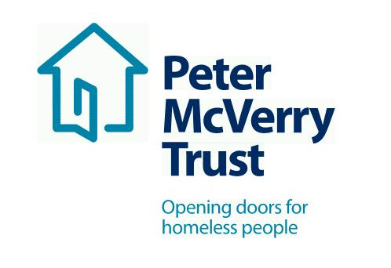

PROJECT WORKER DEVELOPMENT PROGRAMME

Qualifications:

Degree level qualification in Psychology, Social Care, Social Science, Sociology, Social Policy or other related discipline.
No experience required.

Project Worker Development Programme:
As part of our ongoing expansion we are looking to hire a number of recent Graduates in the coming weeks, the roles are for Project Workers and will be in a range of our services to include Housing with Supports and our Emergency Accommodation. We will provide Intensive training to equip you in the role and these are paid posts.

This is an exciting opportunity to work with a leading organisation in the field of social care and inclusion, this opportunity will allow you to develop your professional practice to an exceptional standard and offers you a structured career and professional development path.
About Peter McVerry Trust: Established in 1983 by Fr Peter McVerry the charity works with individuals at risk of, or experiencing homelessness, primarily in the Dublin region. Peter McVerry Trust provides a wide range of services in the areas of prevention, housing, homelessness, under 18s residential and drug treatment.
Our Vision: “An Ireland that supports all those on the margins and upholds their rights to full inclusion in society.”
Our Mission: Peter McVerry Trust is committed to reducing homelessness and the harm caused by drug misuse and social disadvantage. Peter McVerry Trust provides low-threshold entry services, primarily to younger persons with complex needs, and offers pathways out of homelessness based on the principles of the Housing First model and within a framework that is based on equal opportunities, dignity and respect.

- Key Responsibilities and Duties:

- To work for Peter McVerry Trust within the authority delegated to him/her by the Manager/Team Leader/Social Care Leader;
- Meet with the Manager/Team Leader/Social Care Leader at regular intervals regarding the progress of his/her work;
- To assist the Manager/Team Leader/Social Care Leader in the day to day running of the project.

2. To provide direct support to residents through:

- Intervention, support and supervision;
- When required, advocacy and referral to community services;
- Supervising the behavior of the residents at all times;
- Liaising with the appropriate staff in accessing move-on accommodation for the residents;
- Planning recreational and/or group activities.

Person Specification:

Essential competencies:
- Commitment to providing the highest level of service, communication skills– oral, aural and written, openness to change
- Effective team working, professionalism, respect for others, focus on outcomes, contributing to the prevention and management of challenging behaviour and resilience and positive outlook

To apply, please download the PMVT application : Vacancies - Peter McVerry Trust (pmvtrust.ie)
Completed application forms should be sent to recruitment@pmvtrust.ie

Interviews in Progress Currently

Peter McVerry Trust is an Equal Opportunity Employer

Peter McVerry Trust Operations Ltd Registration Number 412953 Charity Number CHY7256

