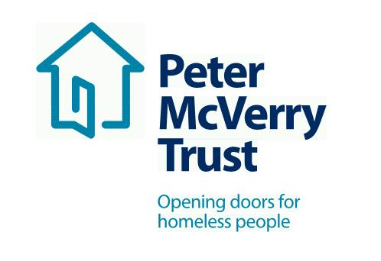

RESETTLEMENT PROJECT WORKERS Kerry

Peter McVerry, the charity works with individuals at risk of, or experiencing homelessness, in Dublin, Kildare, Laois and Limerick. Peter McVerry Trust provides a wide range of services in the areas of homelessness prevention, Family Services ,housing, homeless services, under 18s residential and drug treatment.
Our Vision: “An Ireland that supports all those on the margins and upholds their rights to full inclusion in society.”
Our Mission: Peter McVerry Trust is committed to reducing homelessness, the harm caused by drug misuse and social disadvantage. Peter McVerry Trust provides low-threshold entry services, primarily to younger persons with complex needs, and offers pathways out of homelessness based on the principles of the Housing First model within a framework that is based on equal opportunities, dignity and respect.

Benefits Package:
- Attractive Salary
- Core Professional Training and CPD
- Cycle to Work Scheme and Tax Saver
- Death in Service Benefit
- Employee Assistance Programme
- Career progression opportunities

Key Responsibilities and Duties:

- To work for Peter McVerry Trust within the authority delegated to him/her by the Manager/Team Leader/Social Care Leader;
- Meet with the Manager/Team Leader/Social Care Leader at regular intervals regarding the progress of his/her work;
- To assist the Manager/Team Leader/Social Care Leader in the day to day running of the project.

1.. To provide direct support to clients through:

- Presenting to Accommodation Centres nationwide to assess the housing needs of households and identify most appropriate progression route.
- Assessing the housing need of households accessing Direct Provision and engaging with them to progress them into Private Rented Accommodation via HAP / Homeless HAP.
- Identifying and removing blocks to accessing Social Housing for those in Direct Provision i.e. the unique paperwork relevant to this client group.
- Working closely with Local Authorities to identify progression routes for participants, and to nurture the relationship with Local Authority staff for ease of progression.
- Priority case load; both external and internal – to identify the presenting needs of the potentially complex/ sensitive case and put appropriate interventions in place to support the participant. i.e. presenting to a Local Authority, offering viewings, liaising with landlords/ agents on their behalf, setting up a daft account.
- Sourcing properties and making and nurturing connections with Landlords and Estate Agents in order to progress individuals from homelessness into independent living
- Dealing with participants and landlords. Negotiate, liaise, communicate and co-ordinate with tenants and landlords prior to tenancy commencement. Co-ordinating lease agreement, meeting times, key collection etc. Where required, negotiate, liaise and communicate with tenants and agencies involved in the project.
- To manage time effectively to maximise your working day while commuting.

2. To assist with residents’ case work through:

- Maximising the Social Housing Applicants chances of being housed i.e. identifying HAP eligibility, Senior Housing, best areas to have noted on Housing List Application, applying for Co-operative and Voluntary Housing, Choice Based Lettings etc.
- To advocate on behalf of the client group to external agencies.
- To inform households exiting Direct Provision of their entitlements.

3. To undertake administrative duties through:
- Keeping relevant files up to date, in order to track progressions, viewings sourced and to reflect the success of the Resettlement team.
- Working towards an agreed target as outlined by project Manager.

4. Change in work programme:

It may be necessary, from time to time, for workload to be re-prioritised in order to accommodate workloads in other areas of the organization. Due notice and consultation will be given.

5. To have a positive and enthusiastic attitude in work:

- In your interactions with management, staff and residents of the Peter McVerry Trust.
- In your interactions with external agencies while representing the Peter McVerry Trust.

6. Other Duties:

Any other duties as designated by the Manager/Team Leader/Social Care Leader.

Essential competencies:
- Commitment to providing the highest level of service, communication skills– oral, aural and written, openness to change
- Effective team working, professionalism, respect for others, focus on outcomes, contributing to the prevention and management of challenging behaviour and resilience and positive outlook

Person Specification:

Qualifications and Experience:

- Degree level qualified in social care/youth work, addiction studies or related field;
- Essential competencies: Commitment to providing the highest level of service, respect for others, openness to change, communication skills– oral, aural and written, contributing to the prevention and management of challenging behavior, professionalism & maintaining professional boundaries and effective team working. (All other competencies to be reviewed as part of the supervision and support process);
- Ability to work independently and within a team environment and exercise mature judgement;
- Knowledge of the Immigration System and the Asylum process in Ireland is desirable.
- The ability to work independently, while keeping in contact with the team via phone and email.
- To develop your role as part of the team, and to use your initiative in order to receive the best outcomes for the client group

Requirements of the role:
- Driver
- Nationwide role
- The ability to commute.
- To work flexibly as required around location and evening work.

To apply please download the application form at: Vacancies - Peter McVerry Trust (pmvtrust.ie)
Completed application forms should be sent to recruitment@pmvtrust.ie

Peter McVerry Trust is an Equal Opportunity Employer

Closing date 15th January 2021

Peter McVerry Trust Operations Ltd Registration Number 412953 Charity Number CHY7256

Closing Date for Applications 20th December 2021

