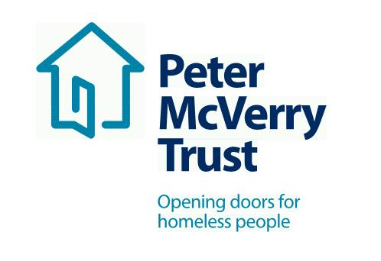

RESETTLEMENT PROJECT WORKERS DUBLIN

Peter McVerry, the charity works with individuals at risk of, or experiencing homelessness, in Dublin, Kildare, Laois and Limerick. Peter McVerry Trust provides a wide range of services in the areas of homelessness prevention, Family Services ,housing, homeless services, under 18s residential and drug treatment.
Our Vision: “An Ireland that supports all those on the margins and upholds their rights to full inclusion in society.”
Our Mission: Peter McVerry Trust is committed to reducing homelessness, the harm caused by drug misuse and social disadvantage. Peter McVerry Trust provides low-threshold entry services, primarily to younger persons with complex needs, and offers pathways out of homelessness based on the principles of the Housing First model within a framework that is based on equal opportunities, dignity and respect.

Benefits Package:
- Attractive Salary
- Core Professional Training and CPD
- Cycle to Work Scheme and Tax Saver
- Death in Service Benefit
- Employee Assistance Programme
- Career progression opportunities

Key Responsibilities and Duties:

- To work for Peter McVerry Trust within the authority delegated to him/her by the Manager/Team Leader/Social Care Leader;
- Meet with the Manager/Team Leader/Social Care Leader at regular intervals regarding the progress of his/her work;
- To assist the Manager/Team Leader/Social Care Leader in the day to day running of the project.

1.. To provide direct support to clients through:

- Presenting to Accommodation Centres nationwide to assess the housing needs of households and identify most appropriate progression route.
- Assessing the housing need of households accessing Direct Provision and engaging with them to progress them into Private Rented Accommodation via HAP / Homeless HAP.
- Identifying and removing blocks to accessing Social Housing for those in Direct Provision i.e. the unique paperwork relevant to this client group.
- Working closely with Local Authorities to identify progression routes for participants, and to nurture the relationship with Local Authority staff for ease of progression.
- Priority case load; both external and internal – to identify the presenting needs of the potentially complex/ sensitive case and put appropriate interventions in place to support the participant. i.e. presenting to a Local Authority, offering viewings, liaising with landlords/ agents on their behalf, setting up a daft account.
- Sourcing properties and making and nurturing connections with Landlords and Estate Agents in order to progress individuals from homelessness into independent living
- Dealing with participants and landlords. Negotiate, liaise, communicate and co-ordinate with tenants and landlords prior to tenancy commencement. Co-ordinating lease agreement, meeting times, key collection etc. Where required, negotiate, liaise and communicate with tenants and agencies involved in the project.
- To manage time effectively to maximise your working day while commuting.

2. To assist with residents’ case work through:

- Maximising the Social Housing Applicants chances of being housed i.e. identifying HAP eligibility, Senior Housing, best areas to have noted on Housing List Application, applying for Co-operative and Voluntary Housing, Choice Based Lettings etc.
- To advocate on behalf of the client group to external agencies.
- To inform households exiting Direct Provision of their entitlements.

3. To undertake administrative duties through:
- Keeping relevant files up to date, in order to track progressions, viewings sourced and to reflect the success of the Resettlement team.
- Working towards an agreed target as outlined by project Manager.

4. Change in work programme:

It may be necessary, from time to time, for workload to be re-prioritised in order to accommodate workloads in other areas of the organization. Due notice and consultation will be given.

5. To have a positive and enthusiastic attitude in work:

- In your interactions with management, staff and residents of the Peter McVerry Trust.
- In your interactions with external agencies while representing the Peter McVerry Trust.

6. Other Duties:

Any other duties as designated by the Manager/Team Leader/Social Care Leader.

Essential competencies:
- Commitment to providing the highest level of service, communication skills– oral, aural and written, openness to change
- Effective team working, professionalism, respect for others, focus on outcomes, contributing to the prevention and management of challenging behaviour and resilience and positive outlook

Person Specification:

Qualifications and Experience:

- Degree level qualified in social care/youth work, addiction studies or related field;
- Essential competencies: Commitment to providing the highest level of service, respect for others, openness to change, communication skills– oral, aural and written, contributing to the prevention and management of challenging behavior, professionalism & maintaining professional boundaries and effective team working. (All other competencies to be reviewed as part of the supervision and support process);
- Ability to work independently and within a team environment and exercise mature judgement;
- Knowledge of the Immigration System and the Asylum process in Ireland is desirable.
- The ability to work independently, while keeping in contact with the team via phone and email.
- To develop your role as part of the team, and to use your initiative in order to receive the best outcomes for the client group

Requirements of the role:
- Driver
- Nationwide role
- The ability to commute.
- To work flexibly as required around location and evening work.

To apply, please download the PMVT application Peter McVerry Trust Jobs | Vacancies in Project Work, Nursing & Housing (pmvtrust.ie)
Completed application forms should be sent to recruitment@pmvtrust.ie or to the HR Department, 29 Mountjoy Square, Dublin 1

Peter McVerry Trust is an Equal Opportunity Employer

Peter McVerry Trust Operations Ltd Registration Number 412953 Charity Number CHY7256

Closing Date for Applications Tuesday 31st May 2022

