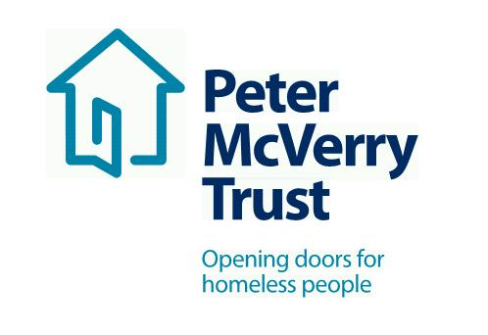

SOCIAL CARE WORKER Under 18s Residential Services

Title of Post: Social Care Worker Under 18s Residential Services
Reporting: Service Manager/Deputy Manager/Social Care leader
Hours of Work: Residential

This is an exciting opportunity to work with a leading organisation in the field of social care and inclusion, this opportunity will allow you to develop your professional practice to an exceptional standard and offers you a structured career and professional development path .

Benefits Package:
- Attractive Salary
- Core Professional Training and CPD
- Cycle to Work Scheme and Tax Saver
- Death in Service Benefit
- Employee Assistance Programme
- Career progression opportunities
About Peter McVerry Trust: Established in 1983 by Fr Peter McVerry the charity works with individuals at risk of, or experiencing homelessness, primarily in the Dublin region. Peter McVerry Trust provides a wide range of services in the areas of prevention, housing, homelessness, Under 18s residential and drug treatment.
Our Vision: “An Ireland that supports all those on the margins and upholds their rights to full inclusion in society.”
Our Mission: Peter McVerry Trust is committed to reducing homelessness and the harm caused by drug misuse and social disadvantage. Peter McVerry Trust provides low-threshold entry services, primarily to younger persons with complex needs, and offers pathways out of homelessness based on the principles of the Housing First model and within a framework that is based on equal opportunities, dignity and respect.

Peter McVerry Trust Under 18s Residential Services:
PMVT Under 18s services offer individualised, holistic, strengths’ based care and support to young people between 12-17 years of age who are referred by Tusla on a short or medium to long term basis. Placements are guided by the Well Tree Model of Care, which is a trauma and attachment informed approach and framework which supports individualised planning and intervention for each young person. PMVT Under 18s services aim to support young people who present with a wide range of needs. Our services work with the young person to continually develop and increase confidence, coping strategies and self-esteem and support the young person to move on to appropriate accommodation following their placement.

Person Specification:

Qualifications and Experience:

- Degree level qualification in Social Care, Youth and Community, Psychology, Child and Adolescent Psychotherapy, Social Work, Social Sciences, Teaching & Nursing .
- Previous Experience in Under 18s Residential Services desirable

Essential Competencies:
- Commitment to providing the highest level of service, communication skills– oral, aural and written, openness to change
- Effective team working, professionalism, respect for others, focus on outcomes, contributing to the prevention and management of challenging behaviour and resilience and positive outlook

To apply, please download the PMVT application form Vacancies - Peter McVerry Trust (pmvtrust.ie)
Completed application forms should be sent to recruitment@pmvtrust.ie Full Job Description available.

Closing Date for Applications Tuesday 31st May 2022

Interviews currently in Progress

Peter McVerry Trust is an Equal Opportunity Employer

