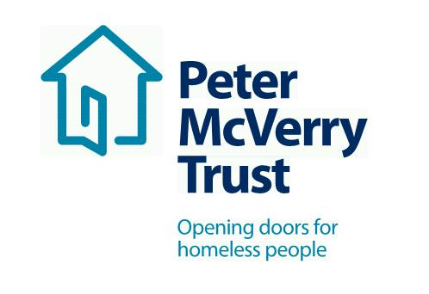

SOCIAL CARE MANAGER Under 18s Residential Services

Title of Post: Frontline Manager/SCM with Responsibility for Under 18s Residential Service
Location: Limerick
Reporting: Head of Services with Special Responsibility for Under 18s Service

This is an exciting opportunity to work with a leading organisation in the field of social care and inclusion, this opportunity will allow you to develop your professional practice to an exceptional standard and offers you a structured career and professional development path.

Benefits Package:
- Attractive Salary
- Core Professional Training and CPD
- Cycle to Work Scheme and Tax Saver
- Death in Service Benefit
- Employee Assistance Programme
- Career progression opportunities
About Peter McVerry Trust: Established in 1983 by Fr Peter McVerry the charity works with individuals at risk of, or experiencing homelessness, primarily in the Dublin region. Peter McVerry Trust provides a wide range of services in the areas of prevention, housing, homelessness, Under 18s residential and drug treatment.
Our Vision: “An Ireland that supports all those on the margins and upholds their rights to full inclusion in society.”
Our Mission: Peter McVerry Trust is committed to reducing homelessness and the harm caused by drug misuse and social disadvantage. Peter McVerry Trust provides low-threshold entry services, primarily to younger persons with complex needs, and offers pathways out of homelessness based on the principles of the Housing First model and within a framework that is based on equal opportunities, dignity and respect.

Peter McVerry Trust Under 18s Residential Services:
PMVT Under 18s services offer individualised, holistic, strengths’ based care and support to young people between 12-17 years of age who are referred by Tusla on a short term basis. Placements are guided by the Well Tree Model of Care, which is a trauma and attachment informed approach and framework which supports individualised planning and intervention for each young person. PMVT Under 18s services aim to support young people who present with a wide range of needs. Our services work with the young person to continually develop and increase confidence, coping strategies and self-esteem and support the young person to move on to appropriate accommodation following their placement.

Person Specification:

Qualifications and Experience:

- A minimum of degree level qualification in a relevant discipline e.g. Child/Social Care, Social work etc.
- Essential competencies: Commitment to providing the highest level of service, respect for others, openness to change, communication skills– oral, aural and written, contributing to the prevention and management of challenging behavior, professionalism & maintaining professional boundaries, effective team working, focusing on outcomes, analysis and problem solving, initiative and taking responsibility and leadership (All other competencies to be reviewed as part of the supervision and support process.
- A minimum of 5 years relevant post qualification experience working in residential services with children/young people at a social care grade , ideally with some supervisory experience.
- A minimum of two years supervisory experience and a proven track record in leading and motivating staff.
- Currently operating at front-line management, social care leader or team leader level.
- The candidate should be an excellent communicator and possess strong interpersonal skills.
- A management qualification is desirable.

To apply, please download the PMVT application form from Peter McVerry Trust Jobs | Vacancies | (pmvtrust.ie).
Completed application forms should be sent to recruitment@pmvtrust.ie

Closing Date for Applications 15th June 2022

Peter McVerry Trust is an Equal Opportunity Employer

Peter McVerry Trust Operations Ltd Registration Number 412953 Charity Number CHY7256

