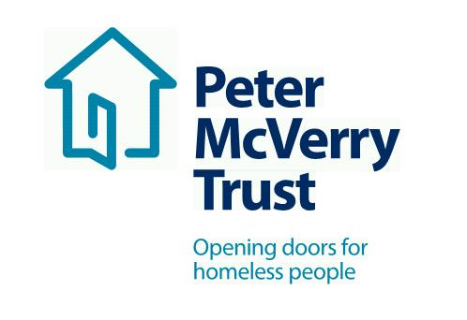

Healthcare Assistant

Title of Post: Healthcare Assistant Contract and Relief
Location: North Dublin
About Peter McVerry Trust: Established in 1983 by Fr Peter McVerry, the charity works with individuals at risk of, or experiencing homelessness, in Dublin, Kildare, Laois and Limerick. Peter McVerry Trust provides a wide range of services in the areas of homelessness prevention, Family Services, housing, homeless services, under 18s residential and drug treatment.
Our Vision: “An Ireland that supports all those on the margins and upholds their rights to full inclusion in society.”
Our Mission: Peter McVerry Trust is committed to reducing homelessness, the harm caused by drug misuse and social disadvantage. Peter McVerry Trust provides low-threshold entry services, primarily to younger persons with complex needs, and offers pathways out of homelessness based on the principles of the Housing First model within a framework that is based on equal opportunities, dignity and respect.

- Key Responsibilities and Duties:
- To work for Peter McVerry Trust within the authority delegated to him/her by the Manager/Team Leader/Social Care Leader;
- To work as part of a team of Health Care Assistants, under the direction of the Nursing team.
- To provide quality person centered care to meet the needs of residents in order for them to continue living independently with privacy and dignity.
- To promote a caring environment for residents through high standards of professional practice which are conducive to the physical, emotional, social, intellectual and spiritual needs of the service users.
- To provide high standard services as specified in agreed care plans and to contribute to the continual review of resident’s needs.

- To maintain a safe and healthy living environment through:

- Adherence to safety and security protocols;
- Ensuring that the environment is maintained to a high standard at all times;
- Assigning routine tasks and domestic duties to residents;
- Keeping stock of household necessities and purchasing weekly groceries;
- Providing meals along with residents to support the development of independent living skills;
- Advice and help to residents with housekeeping needs;
- Mediating disputes and encouraging co-operation.

- Change in work programme:

- It may be necessary, from time to time, for workload to be re-prioritised in order to accommodate workloads in other areas of the organization. Due notice and consultation will be given.

- To have a positive and enthusiastic attitude in work:

- In your interactions with management, staff and residents of the Peter McVerry Trust.
- In your interactions with external agencies while representing the Peter McVerry Trust.

- Other Duties:

- Any other duties as designated by the Manager/Team Leader/Social Care Leader.

Person Specification:

Qualifications and Experience:
- QQI Level 5 in Healthcare, Pre-Nursing or those who are working towards the qualification.
- Previous nursing home experience an advantage.
- The desire to be part of a team
- Genuine passion for working in healthcare and to provide person centered care
- Willingness to work hard and be actively involved in the business
- Experience with Neuro/Rehab and Acquired Brain Injury an advantage

To apply, please download the PMVT application form from http://www.pmvtrust.ie/about-us/vacancies/. Completed application forms should be sent to recruitment@pmvtrust.ie

Peter McVerry Trust is an Equal Opportunity Employer

Peter McVerry Trust Operations Ltd Registration Number 412953 Charity Number CHY7256

