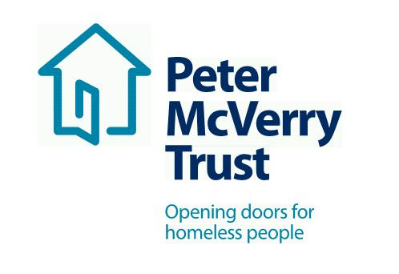

Title of Post: Project Workers FAMILY SERVICE GALWAY
Reporting: Service Manager/Team Leader/Social Care leader
Hours of Work: Residential

This is an exciting opportunity to work with a leading organisation in the field of social care and inclusion, this opportunity will allow you to develop your professional practice to an exceptional standard and offers you a structured career and professional development path .

No previous experience required, role would suit recent Graduates

Benefits Package:
- Attractive Salary
- Core Professional Training and CPD
- Cycle to Work Scheme and Tax Saver
- Death in Service Benefit
- Employee Assistance Programme
- Career progression opportunities
About Peter McVerry Trust: Established in 1983 by Fr Peter McVerry the charity works with individuals at risk of, or experiencing homelessness, primarily in the Dublin region. Peter McVerry Trust provides a wide range of services in the areas of prevention, housing, homelessness, under 18s residential and drug treatment.
Our Vision: “An Ireland that supports all those on the margins and upholds their rights to full inclusion in society.”
Our Mission: Peter McVerry Trust is committed to reducing homelessness and the harm caused by drug misuse and social disadvantage. Peter McVerry Trust provides low-threshold entry services, primarily to younger persons with complex needs, and offers pathways out of homelessness based on the principles of the Housing First model and within a framework that is based on equal opportunities, dignity and respect.

Key Responsibilities and Duties:

- To work for Peter McVerry Trust within the authority delegated to him/her by the Manager/Team Leader/Social Care Leader;
- Meet with the Manager/Team Leader/Social Care Leader at regular intervals regarding the progress of his/her work;
- To assist the Manager/Team Leader/Social Care Leader in the day to day running of the project.

2. To provide direct support to residents through:

- Intervention, support and supervision;
- When required, advocacy and referral to community services;
- Supervising the behavior of the residents at all times;
- Liaising with the appropriate staff in accessing move-on accommodation for the residents;
- Planning recreational and/or group activities.

3. To assist with residents’ case work through:

- Communication with staff of Peter McVerry Trust where relevant
- Assisting with resident’s Individual Personal Plans;
- Ensuring that residents are fully informed about all entitlements.

4. To maintain a safe and healthy living environment through:

- Adherence to safety and security protocols;
- Ensuring that the environment is maintained to a high standard at all times;
- Assigning routine tasks and domestic duties to residents;
- Keeping stock of household necessities and purchasing weekly groceries;
- Providing meals along with residents to support the development of independent living skills;
- Advice and help to residents with housekeeping needs;
- Mediating disputes and encouraging co-operation.

5. To respond to requests for service through:

- Links with other Peter Mc Verry Trust services, screening and assessment;
- Communication of information and referral to resources;
- Offering ongoing support to former residents.

6. To undertake administrative duties through:

- Maintaining residents’ details and documentation;
- Actively participating in staff meetings;
- Providing written reports to the Manager/ Team Leader/Social Care Leader where necessary;
- Recording any Incidents / Accidents that may occur.

7. Change in work programme:

- It may be necessary, from time to time, for workload to be re-prioritised in order to accommodate workloads in other areas of the organization. Due notice and consultation will be given.

8. To have a positive and enthusiastic attitude in work:

- In your interactions with management, staff and residents of the Peter McVerry Trust.
- In your interactions with external agencies while representing the Peter McVerry Trust.

9. Other Duties:

- Any other duties as designated by the Manager/Team Leader/Social Care Leader.

Person Specification:

Qualifications and Experience:

- Degree level qualification in Social Care, Youth and Community. Early Childhood, Social Science, Sociology or other related discipline

Essential competencies:
- Commitment to providing the highest level of service, communication skills– oral, aural and written, openness to change
- Effective team working, professionalism, respect for others, focus on outcomes, contributing to the prevention and management of challenging behaviour and resilience and positive outlook

To apply please download the application form at: Vacancies - Peter McVerry Trust (pmvtrust.ie)
Completed application forms should be sent to recruitment@pmvtrust.ie

Peter McVerry Trust is an Equal Opportunity Employer

Peter McVerry Trust Operations Ltd Registration Number 412953 Charity Number CHY7256

